**SOFTWARE ENGINERRING METHODOLOGY**

I have decided to work with the **Waterfall Methodology** because it follows sequential approach to developing the Software, where each phase of the project (such as planning, design, implementation, testing, and maintenance) is completed before moving on to the next phase. The waterfall model is suitable for projects where the requirements are well-defined, and there is little chance of change during the project's lifecycle.

**Context models**

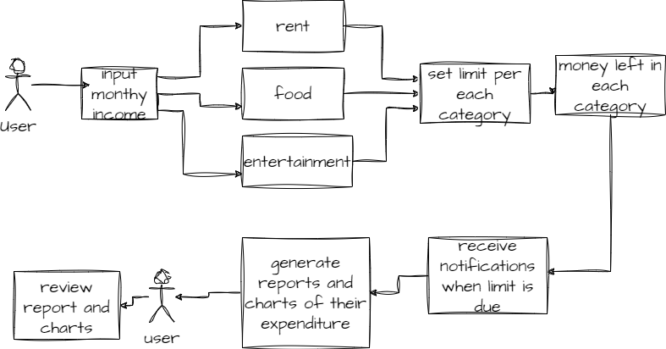

**Interaction models**

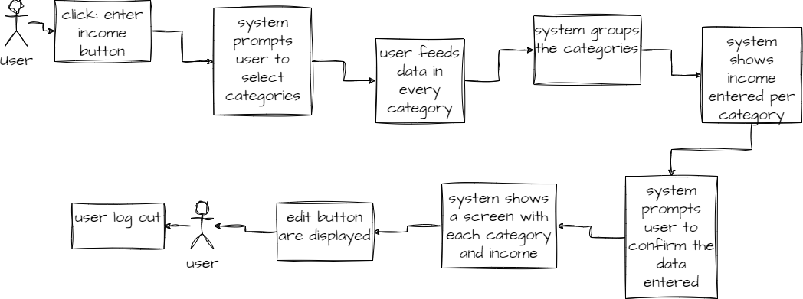

**Structural models**

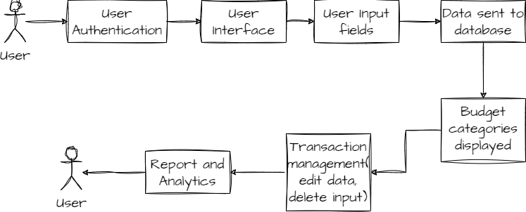

**Behavioral models**

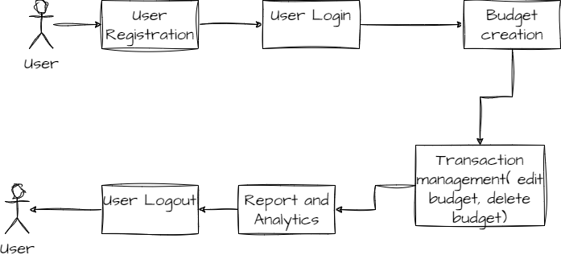

**Structural models**

**Interaction models**

